Concat Command

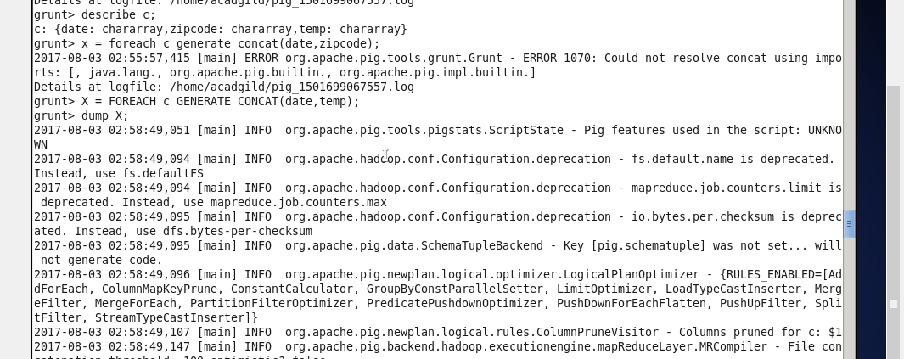

Output:

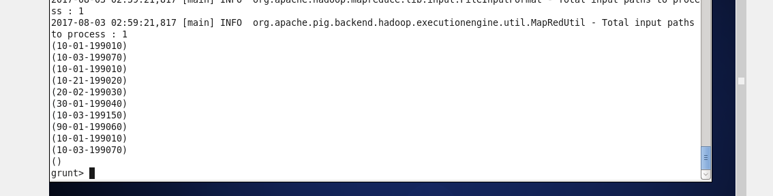

SUM Command

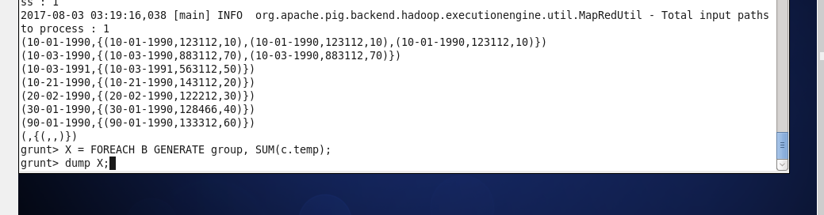

Output:

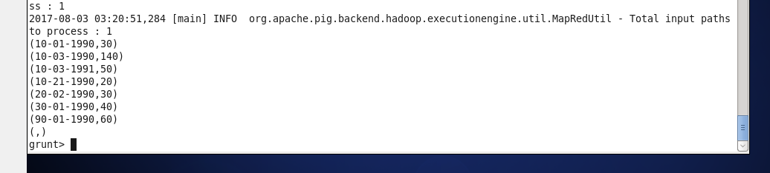

MIN Commands:

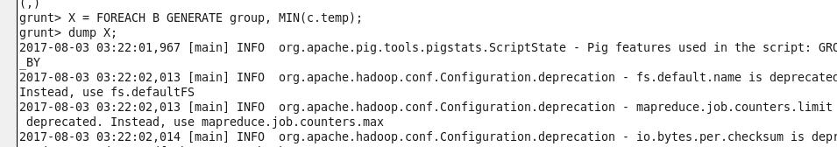

Output:

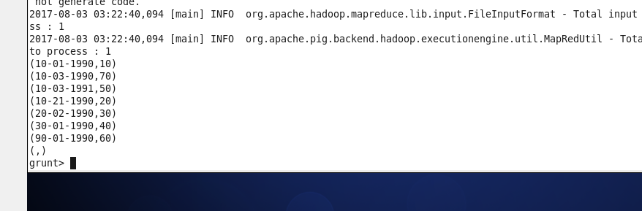

MAX Command:

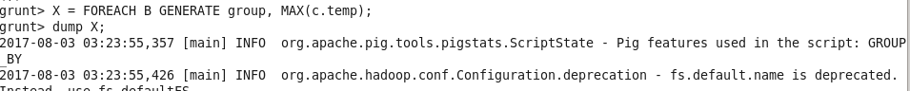

Output:

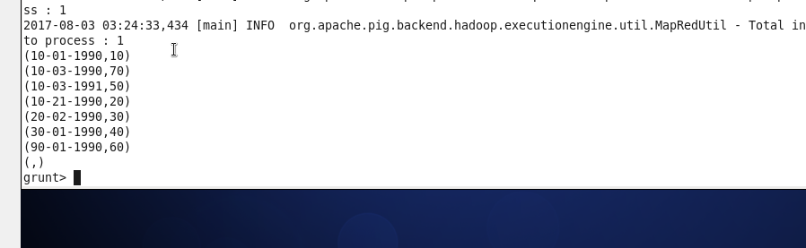

LIMIT Command:

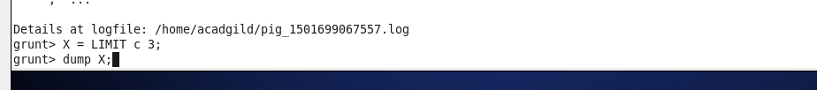

Output:

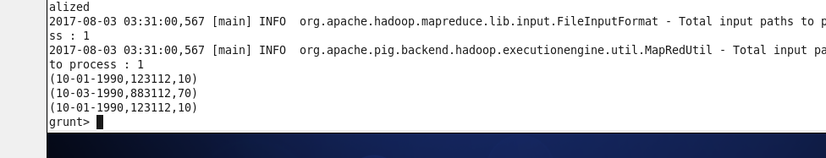

STORE command:



Output:

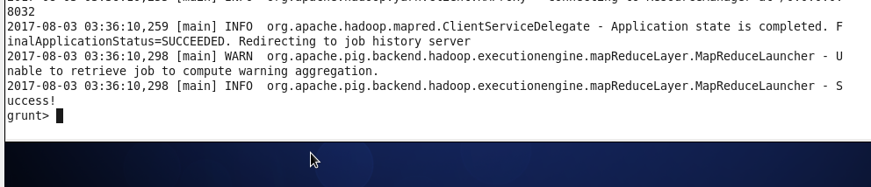

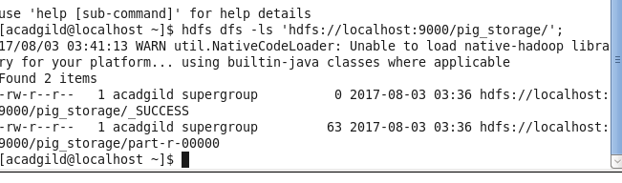

DISTINCT command:



Output:

